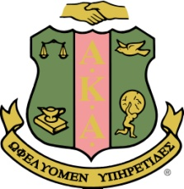
Alpha Kappa Alpha Sorority Incorporated
Epsilon Pi Omega Chapter

Deborah S. Padmore President Sharon M. Nichols Vice President Kim Adams, AKA Connections Chairperson
The Great Community Resource Fair
Monday, January 18, 2016 1:00pm-4:00pm
Oratorical Application

Name _____________________________________________

Age_____________________

School __________________________________________

Grade _________________

Parent / Guardian’s Name _________________________________________
Parent/ Guardian’s Phone Number _______-__________________________
Parent/ Guardian’s Email Address ______________________________-____
Additional Information ____________________________________________

Please complete and email to Kim2020@verizon.net

